**Quick sort**

Quick sort is a highly efficient sorting algorithm and is based on partitioning of array of data into smaller arrays. A large array is partitioned into two arrays one of which holds values smaller than the specified value, say pivot, based on which the partition is made and another array holds values greater than the pivot value. QuickSort is a Divide and Conquer algorithm. It picks an element as pivot and partitions the given array around the picked pivot. There are many different versions of quickSort that pick pivot in different ways.

1. Always pick first element as pivot.
2. Always pick last element as pivot (implemented below)
3. Pick a random element as pivot.
4. Pick median as pivot.

**Example**

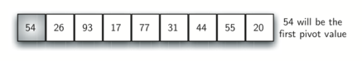

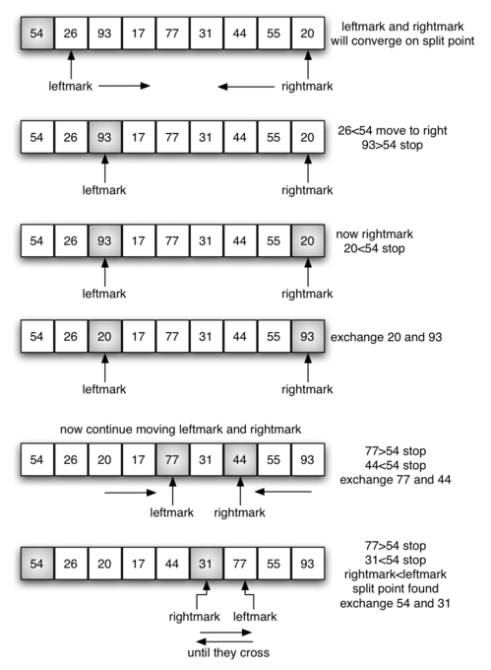

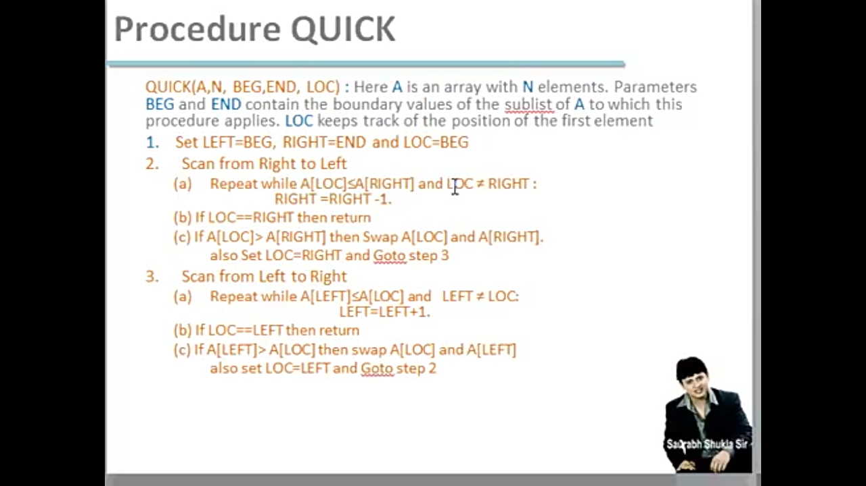

**Complexity of the Quick Sort Algorithm**

**Worst Case : O(n2)**  
**Best Case : O (n log n)**  
**Average Case : O (n log n)**